Module 3 -Symmetric Encryption Algorithms

Slide 3 - Symmetric encryption

Symmetric algorithms use the same key to encrypt and decrypt the plaintext on both ends of the process. Both the sender and receiver know the pre-shared key before any encrypted communication begins. Encryption algorithms that use a common key are simpler and need less computational power.

This is the simplest kind of encryption that involves only one secret key to cipher and decipher information. Symmetric encryption is an old and best-known technique. The secret key that can either be a number, a word or a string of random letters.

Slide 4 - Symmetric encryption - figure

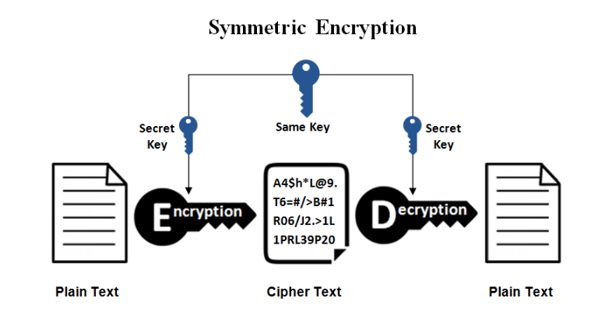

With secret-key cryptography, both communicating parties, Alice and Bob, use the same key to encrypt and decrypt the messages. Before any encrypted data can be sent over the network, both Alice and Bob must have the key and must agree on the cryptographic algorithm that they will use for encryption and decryption.

One of the major problems with secret-key cryptography is the logistical issue of how to get the key from one party to the other without allowing access to an attacker. If Alice and Bob are securing their data with secret-key cryptography, and if Charles gains access to their key, then Charles can understand any secret messages he intercepts between Alice and Bob. Not only can Charles decrypt Alice's and Bob's messages, but he can also pretend that he is Alice and send encrypted data to Bob. Bob won’t know that the message came from Charles, not Alice.

After the problem of secret key distribution is solved, secret-key cryptography can be a valuable tool. The algorithms provide excellent security and encrypt data relatively quickly. The majority of the sensitive data sent in an TLS session is sent using secret-key cryptography.

Slide 5 - Symmetric encryption algorithms

Stream and block are the two types of symmetric algorithms.
Block algorithms - Set lengths of bits are encrypted in blocks of electronic data with the use of a specific secret key. As the data is being encrypted, the system holds the data in its memory as it waits for complete blocks.

Stream algorithms - Data is encrypted as it streams instead of being retained in the system’s memory.

Slide 6 - Symmetric encryption algorithms

Some examples of symmetric encryption algorithms include:

DES (Data Encryption Standard)
Triple Data Encryption Algorithm (TDEA)
IDEA (International Data Encryption Algorithm)
Blowfish (Drop-in replacement for DES or IDEA)
Twofish
RC4 (Rivest Cipher 4)
RC5 (Rivest Cipher 5)
RC6 (Rivest Cipher 6)

AES, DES, IDEA, Blowfish, RC5 and RC6 are block ciphers. RC4 is a stream cipher.

Slide 7 - Symmetric encryption algorithms - figure

The classification of cryptographic algorithms along with algorithms examples for each class and the year they are created.

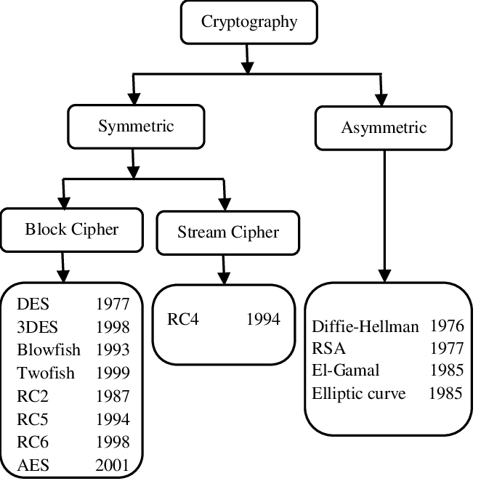

Slide 8 - Feistel cipher

Most of the major symmetric ciphers are based on a cipher known as the Feistel block cipher or Feistel network.

This was a block cipher developed by the IBM cryptography researcher Horst Feistel in the early 70’s . It is considered as a general approach to build a block cipher.

Such a network divides the plain text into fixed size blocks then takes a block of the plaintext and the key as inputs, and applies several iterations called rounds to generate the cipher text.

Each round applies a function (F) that consists of two main operations, substitution (or S-box) and permutation (or P-box). Substitution is a mapping of one value to another whereas permutation is a bit-shuffling process or simply a reordering of the bit positions for each of the inputs.

The block size, key size, the function F and number of rounds vary from one cipher algorithm to another. Generally, the more rounds there are, and the larger the key size is, the more secure a cipher algorithm will be.
Most symmetric encryption schemes today are based on this structure.

Slide 9 - Feistel cipher - figure

Feistel Structure is shown in the figure.

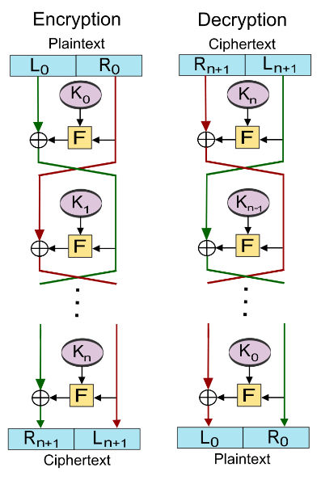

The encryption process uses the Feistel structure consisting of multiple rounds of processing of the plaintext, each round consisting of a “substitution” step followed by a permutation step.

The input block to each round is divided into two halves that can be denoted as L and R for the left half and the right half.

In each round, the right half of the block, R, goes through unchanged, but the left half, L, goes through an operation that depends on R and the encryption key.

The permutation step at the end of each round swaps the modified L and unmodified R. Therefore, the L for the next round would be R of the current round.

The number of rounds are specified by the algorithm design.Once the last round is completed then the two sub blocks, ‘R’ and ‘L’ are concatenated in this order to form the ciphertext block.

The process of decryption in Feistel cipher is almost similar. Instead of starting with a block of plaintext, the ciphertext block is fed into the start of the Feistel structure and then the process thereafter is exactly the same as described in the given illustration.

Slide 11 - Data Encryption Standard (DES)

DES is an outdated symmetric-key block cipher. It was adopted by the National Institute of Standards and Technology in 1977 for government agencies to protect sensitive data and was officially retired in 2005.

DES was the first encryption algorithm the U.S. government approved for public disclosure. This move ensured it was quickly adopted by industries, such as financial services, that needed strong encryption.

Because of its simplicity, DES was also used in a variety of embedded systems, including the following: smart cards, SIM cards, modems, routers, set-top boxes

Slide 12 - The overall Feistel structure of DES (left) and The Feistel function (F-function) of DES (right)

DES is a block cipher, an implementation of a Feistel Cipher. It uses a 16 round Feistel structure. To encrypt a plaintext message, DES groups it into 64-bit blocks. Each block is enciphered using the secret key into a 64-bit ciphertext by means of permutation and substitution.

DES has an effective key length of 56 bits since 8 of the 64 bits of the key are not used by the encryption algorithm (function as check bits only).

The encryption algorithm generates 16 different 48-bit subkeys, one for each of the 16 encryption rounds. Subkeys are generated by selecting and permuting parts of the key as defined by the DES algorithm.

The initial permutation (IP) produces two halves of the permuted block; saying Left Plain Text (LPT) and Right Plain Text (RPT).

Now each LPT and RPT go through 16 rounds of the encryption process.

In the end, LPT and RPT are rejoined and a Final Permutation (FP) is performed on the combined block

The result of this process produces 64-bit ciphertext.

Decryption is simply the inverse of encryption, following the same steps but reversing the order in which the keys are applied.

The heart of this cipher is the DES function, f. The DES function applies a 48-bit key to the rightmost 32 bits to produce a 32-bit output.

Expansion Permutation Box − Since the right input is 32-bit and the round key is 48-bit, we first need to expand the right input to 48 bits. Permutation logic is graphically depicted in the following illustration.

After the expansion permutation, DES does XOR operation on the expanded right section and the round key. The round key is used only in this operation.

DES uses 8 S-boxes, each with a 6-bit input and a 4-bit output. . The output of all eight s-boxes is then combined into a 32 bit section.The 32 bit output of S-boxes is then subjected to the straight permutation.

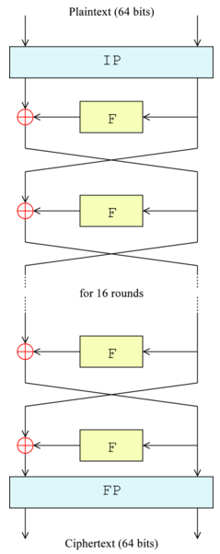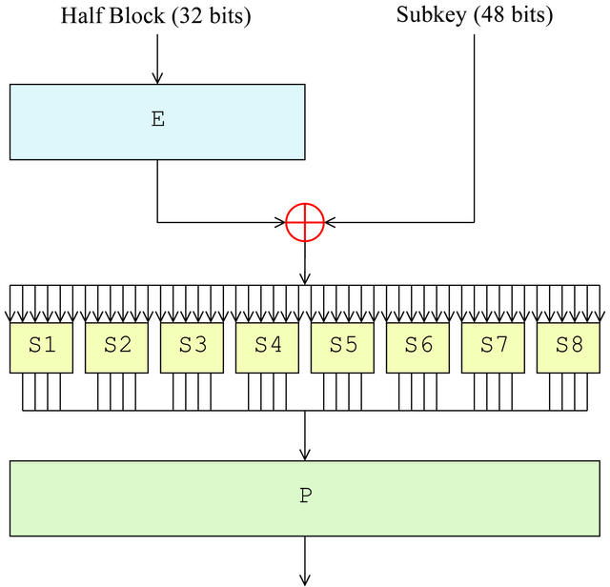
Slide 13 - Triple Data Encryption Algorithm (TDES)

Introduced in 1998, it applies the DES cipher algorithm three times to each data block for more effective key length.

Triple DES operates in three steps: Encrypt-Decrypt-Encrypt (EDE). It works by taking three 56-bit keys (K1, K2 and K3) known as a key bundle and encrypting first with K1, decrypting next with K2 and encrypting a last time with K3. The algorithm is run three times

With Triple DES, each of the three rounds can be run in either direction - encrypt or decrypt - using the DES algorithm. This results in eight different possible modes for Triple DES.

NIST deprecated the algorithm in 2018, however, and Triple DES use will be disallowed after 2023.

Slide 15 - Advanced Encryption Standard (AES)

AES is a symmetric block cipher chosen by the U.S. government to protect classified information.

The National Institute of Standards and Technology (NIST) started development of AES in 1997 when it announced the need for an alternative to the Data Encryption Standard (DES), which was starting to become vulnerable to brute-force attacks.

Fifteen competing symmetric algorithm designs were subjected to preliminary analysis by the world cryptographic community, including the National Security Agency (NSA). n August 1999, NIST selected five algorithms for more extensive analysis:

- MARS, submitted by a large team from IBM Research;
- RC6, submitted by RSA Security;
- Rijndael, submitted by two Belgian cryptographers, Joan Daemen and Vincent Rijmen;
- Serpent, submitted by 3 scientists; and
- Twofish, submitted by a large team of researchers from Counterpane Internet Security, including noted cryptographer Bruce Schneier.

After much feedback, debate and analysis, the Rijndael cipher was selected as the proposed algorithm for AES in October 2000. It was published by NIST as U.S. Federal Information Processing Standards (FIPS) PUB 197, which was accepted by the secretary of commerce in December 2001.

AES became effective as a federal government standard in 2002. It is also included in the International Organization for Standardization (ISO)/International Electrotechnical Commission (IEC) 18033-3 standard, which specifies block ciphers for the purpose of data confidentiality.

In June 2003, the U.S. government announced that AES could be used to protect classified information.

Slide 16 - AES encryption

AES is an iterative rather than Feistel cipher. It is based on the ‘substitution–permutation network’.

It comprises a series of linked operations, some of which involve replacing inputs by specific outputs (substitutions) and others involve shuffling bits around (permutations).

AES includes three block ciphers:

- AES-128 uses a 128-bit key length to encrypt and decrypt a block of messages.
- AES-192 uses a 192-bit key length to encrypt and decrypt a block of messages.
- AES-256 uses a 256-bit key length to encrypt and decrypt a block of messages.

Each cipher encrypts and decrypts data in blocks of 128 bits using cryptographic keys of 128, 192 and 256 bits, respectively.

Symmetric, also known as secret key, ciphers use the same key for encrypting and decrypting. The sender and the receiver must both know -- and use -- the same secret key.

The government classifies information in three categories: Confidential, Secret or Top Secret. All key lengths can be used to protect the Confidential and Secret level. Top Secret information requires either 192- or 256-bit key lengths.

Slide 17 - AES - figure

There are 10 rounds for 128-bit keys, 12 rounds for 192-bit keys and 14 rounds for 256-bit keys.

Each round consists of several processing steps that include substitution, transposition and mixing of the input plaintext to transform it into the final output of ciphertext.

The first step of the cipher is to put the data into an array.

The first transformation in the AES encryption cipher is substitution of data using a substitution table.

The second transformation shifts data rows.

The third mixes columns. The last transformation is performed on each column using a different part of the encryption key. Longer keys need more rounds to complete.

The process of decryption of an AES ciphertext is similar to the encryption process in the reverse order.

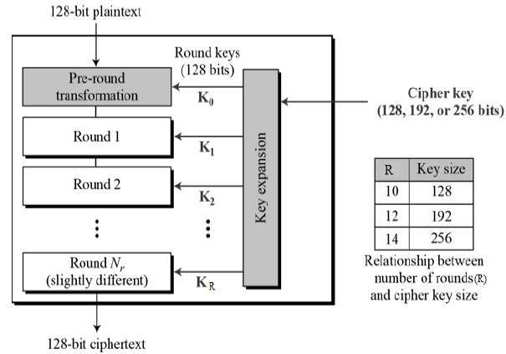

Slide 18 - Features of AES

NIST specified the new AES algorithm must be a block cipher capable of handling 128-bit blocks, using keys sized at 128, 192 and 256 bits.

Other criteria for being chosen as the next AES algorithm included the following:

Security. Competing algorithms were to be judged on their ability to resist attack as compared to other submitted ciphers. Security strength was to be considered the most important factor in the competition.

Cost. Intended to be released on a global, nonexclusive and royalty-free basis, the candidate algorithms were to be evaluated on computational and memory efficiency.

Implementation. Factors to be considered included the algorithm's flexibility, suitability for hardware or software implementation, and overall simplicity.

Slide 19 - The key differences between AES vs. DES

Both are examples of symmetric block ciphers. That is where the similarities end, however. DES is an outdated method of data encryption, and development on AES began in the late 1990s when DES was deemed inadequate from a cybersecurity standpoint.

There is an important difference when comparing AES vs. DES encryption and decryption algorithms: AES is secure, while DES is not.

The federal government developed DES algorithms more than 40 years ago to provide cryptographic security for all government communications. The idea was to ensure government systems all used the same, secure standard to facilitate interconnectivity.

DES served as the cornerstone of government cryptography for more than two decades, but in 1999, researchers broke the algorithm's 56-bit key using a distributed computer system.

When it was initially developed, the DES symmetric-key algorithm was commonly used for data encryption. It was superseded by the more secure AES algorithm when AES became a federal government standard in 2002.

AES is a more mathematically efficient and elegant cryptographic algorithm, but its main strength rests in its key length options.

The time required to crack an encryption algorithm is directly related to the length of the key used to secure the communication. AES allows you to choose a 128-bit, 192-bit or 256-bit key, making it exponentially stronger than the 56-bit key of DES. Encryption is also much faster in AES vs. DES, making it ideal for applications, firmware and hardware that require low latency or high throughput.

Slide 21 - International Data Encryption Algorithm (IDEA)

IDEA is a symmetric key block cipher encryption algorithm designed to encrypt text to an unreadable format for transmission via the internet. It uses a typical block size of 128 bits and takes 64 bits as an input, i.e., 64-bit data. IDEA performs 8.5 identical encryption and decryption rounds using six different subkeys. It uses four keys for output transformation.

First published in 1991 to replace the Data Encryption Standard (DES), IDEA was originally called the Proposed Encryption Standard. The name was changed to Improved Proposed Encryption Standard and eventually to IDEA.

Slide 22 - IDEA figure

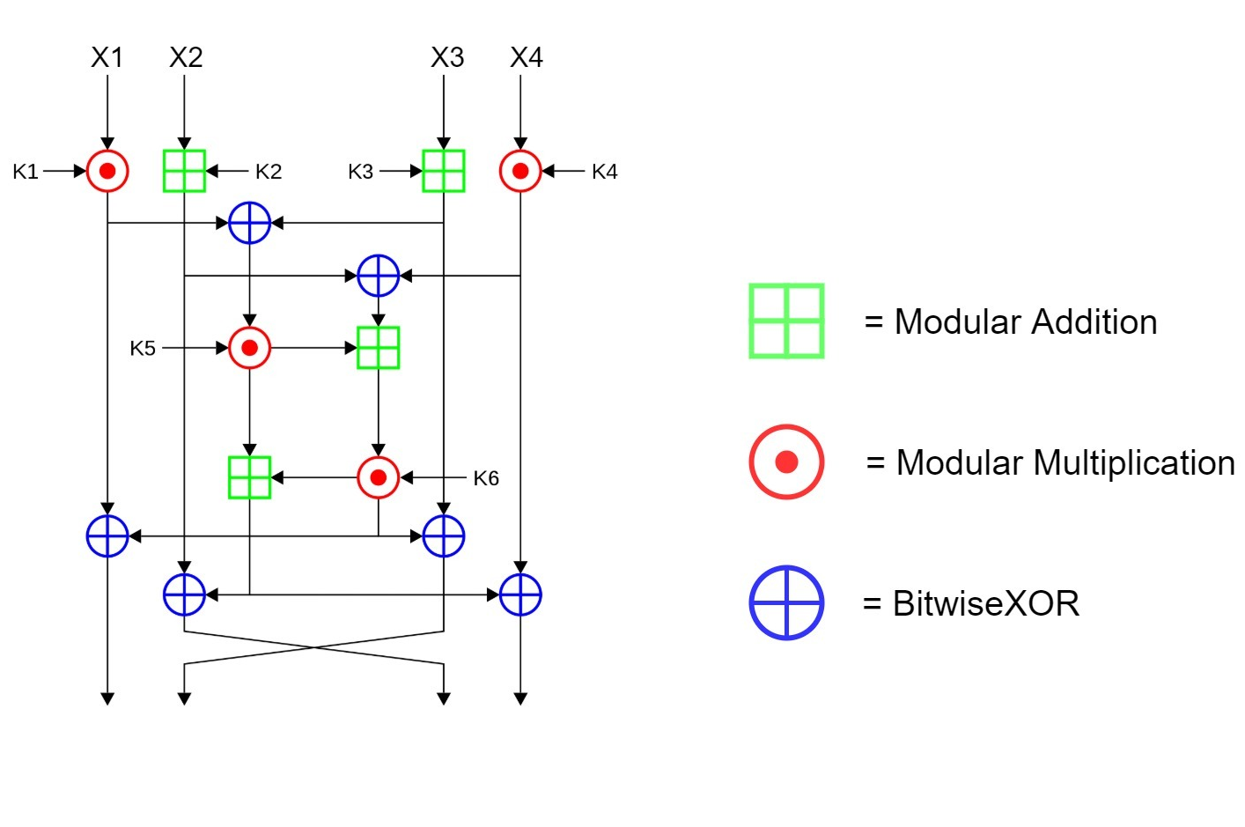

By using a 128-bit key, IDEA encrypts a 64-bit block of plaintext into a 64-bit block of ciphertext consisting of a series of 8 identical transformations (a round) and an output transformation (the half-round).

One process partitions the plaintext block into four 16-bit subblocks for each of the eight complete rounds, namely X1, X2, X3 and X4.

Another process produces six 16-bit key subblocks for each of the encryption rounds. The processes for encryption and decryption are similar.

IDEA derives much of its security by interleaving operations from different groups — modular addition (denoted with a green boxed plus) and multiplication (denoted by a red circled dot), and bitwise eXclusive OR (denoted with a blue circled plus).After the 8 rounds comes a final “half-round”

Slide 23 - Advantages and applications of IDEA

Although IDEA was originally meant to replace DES, it did not do so. Nonetheless, it was incorporated into Pretty Good Privacy, which indicates its reliability and security.

IDEA supports easy hardware and software implementation for quick execution. It can be easily embedded into encryption software to protect data transmission and storage in several real-world applications:
financial services, broadcasting, government, video conferencing, audio and video for cable TV, business TV, voice over IP, email via public, networks, smart cards

Slide 25 - Blowfish

Blowfish is a variable-length, symmetric, 64-bit block cipher. Designed by Bruce Schneier in 1993 as a "general-purpose algorithm," it was intended to provide a fast, free, drop-in alternative to the aging Data Encryption Standard (DES) and International Data Encryption Algorithm (IDEA) encryption algorithms.

Blowfish is significantly faster than DES and IDEA and is unpatented and available free for all uses. However, it couldn't completely replace DES due to its small block size, which is considered insecure.

However, Blowfish encryption has never been broken, and the algorithm is included in many cipher suites and encryption products available today.

Slide 26 - Blowfish

Blowfish features a 64-bit block size and takes a variable-length key, from 32 bits to 448 bits.

It consists of 16 Feistel-like iterations, where each iteration operates on a 64-bit block that's split into two 32-bit words. Blowfish uses a single encryption key to both encrypt and decrypt data.

The Blowfish algorithm consists of two major parts:

Data encryption. Data encryption happens through a 16-round Feistel network, with each round consisting of a key-dependent permutation and a key- and data-dependent substitution. Large, key-dependent S-boxes work with the substitution method and form an integral part of the data encryption system in Blowfish. All encryption operations are XORs -- a type of logic gate -- and additions on 32-bit words.

Key expansion and subkeys. In the key expansion process, maximum size 448-bit keys are converted into several subkey arrays totaling 4,168 bytes. Subkeys form an integral part of the Blowfish algorithm, which uses a large number of them. These subkeys are pre-computed before encryption or decryption can take place.

Slide 27 - Advantages of Blowfish Algorithm

Blowfish is much faster and more efficient than DES and IDEA algorithms.

It is unpatented and can be freely used by anyone even without a license.

Despite the complex initialization phase before encryption, the data encryption process is efficient on large microprocessors;

It provides extensive security for software and applications developed in Java;

It also provides secure access for backup tools; and, finally Blowfish supports secure user authentication for remote access.

Slide 28 - Disadvantages of Blowfish Algorithm

The speed is affected when changing keys.

The key schedule takes a long time.

The small 64-bit block size makes the algorithm vulnerable to birthday attacks, a class of brute-force attacks.

Each new key requires preprocessing equivalent to 4 KB of text, which affects its speed, making it unusable for some applications.

Slide 29 - Applications of Blowfish

Blowfish is suitable for a wide range of applications, including the following:

- bulk encryption
- random bit generation
- packet encryption
- password hashing and management
- mobile processors
- email, file or disk encryption
- data backup
- Secure Shell

Slide 30 - Comparison DES - 3DES - Blowfish - AES

DES is not secure enough. It is because of its short key length and brute force attacks that can crack it easily. Therefore, although 3DES is another alternative, it’s not secure enough either.

While Blowfish is one of the good alternatives, its block size is not sufficient as AES.

We can see the efficiency of AES when we look at the time required to check all possible keys at 50 billion keys per second. Its results are way better than other encryption algorithms even if it uses key size as 128 bits.

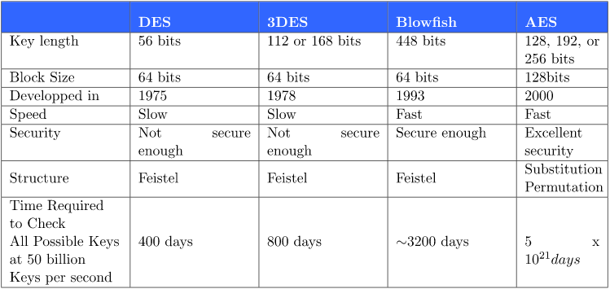

Slide 31 - Pros and cons of symmetric encryption

Pros:

The main advantage of symmetric cryptography is that it is much faster than asymmetric cryptography.
Symmetric encryption is efficient for large amounts of data.

Cons:

Symmetric encryption heavily relies on the fact that the keys must be kept secret. Distributing the key in a secure way is one of the primary challenges of symmetric encryption, which is known as the “key distribution problem.” The key that is the vital component in symmetric cryptography and we cannot afford to lose it or misplace it. If the individual keys are misplaced, the message can be decrypted by malicious actors.

If the secret key used by both parties is compromised, both sides of the transaction are at risk and can be decrypted.

Further, symmetric cryptography ensures only the ‘confidentiality’ of the transmitted or stored data. It cannot be used to ensure integrity and/or authenticity.

HOMEWORK

- Which symmetric encryption algorithm do you think is the most difficult to crack?

- Why is symmetric encryption faster?

